Poetic Test cases

1 login validation

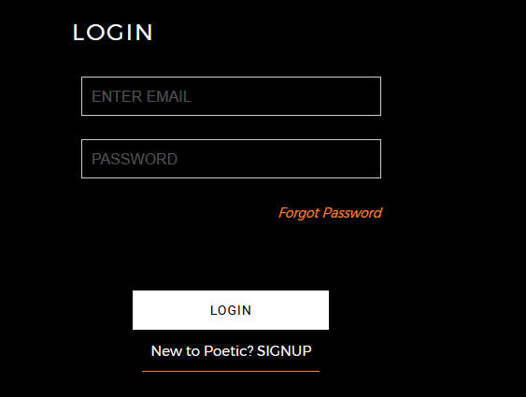

2. register validation

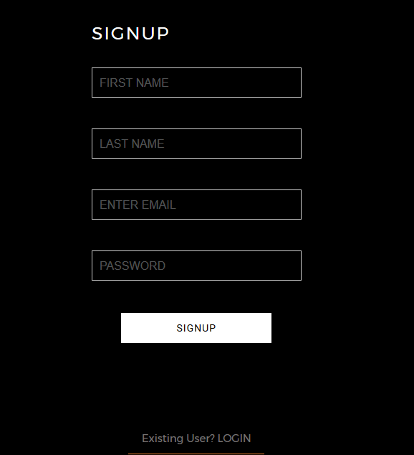

3. forgot validation

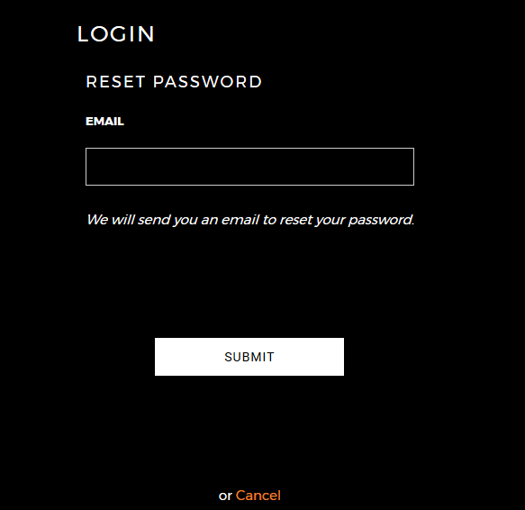

4. cart counting



5. builders and tinkerers and like to do things with an entrepreneurial spirit. This philosophy guides us to be responsible and push boundaries to better ourselves every single day in this awesome journey.

This line is hidden in mobile version

6read about us link shifted towards footer part

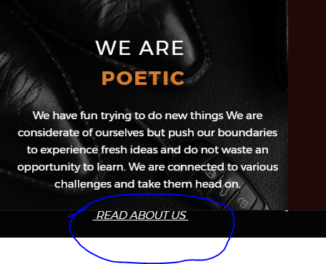

7. difficult to touch in mobile mode



8. Following section is missing in mobile mode

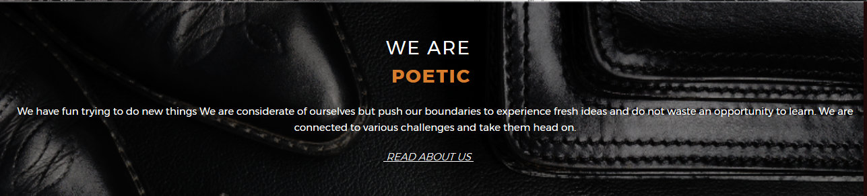

9. no success message after submitting email in forgot password section

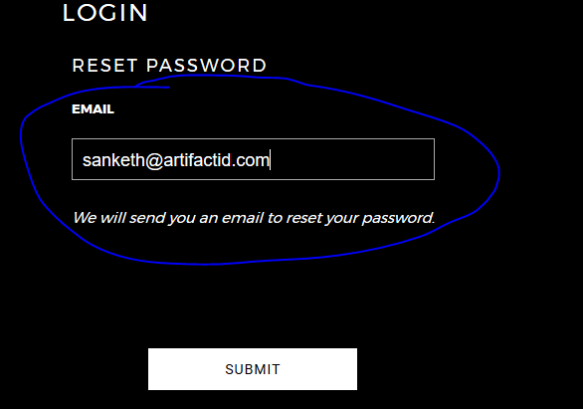

10. there is no link generated to reset the password

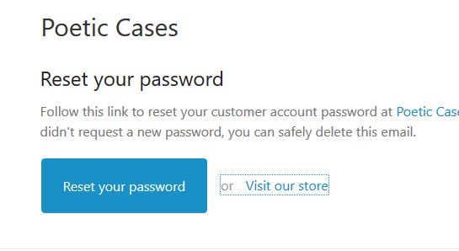

The link redirect to the home page it doesn’t taking into reset page

11. error occurred during reset the password

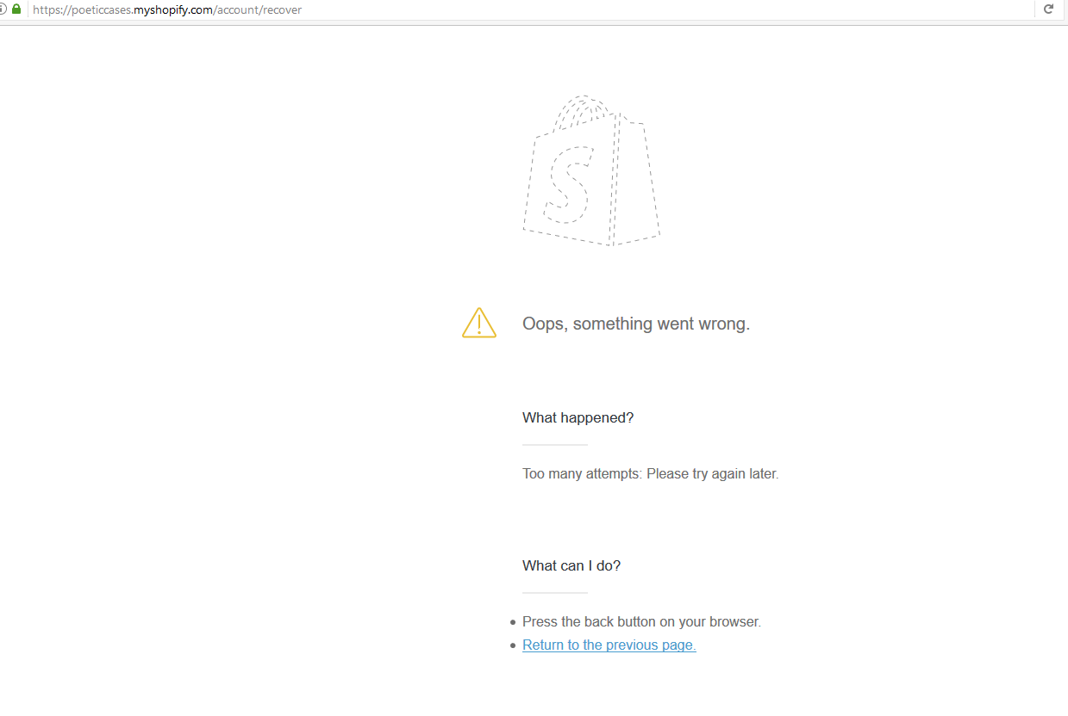

12. it should be a single word

<https://poeticcases.myshopify.com/collections/new-arrivals/products/affinity-samsunggnote5>

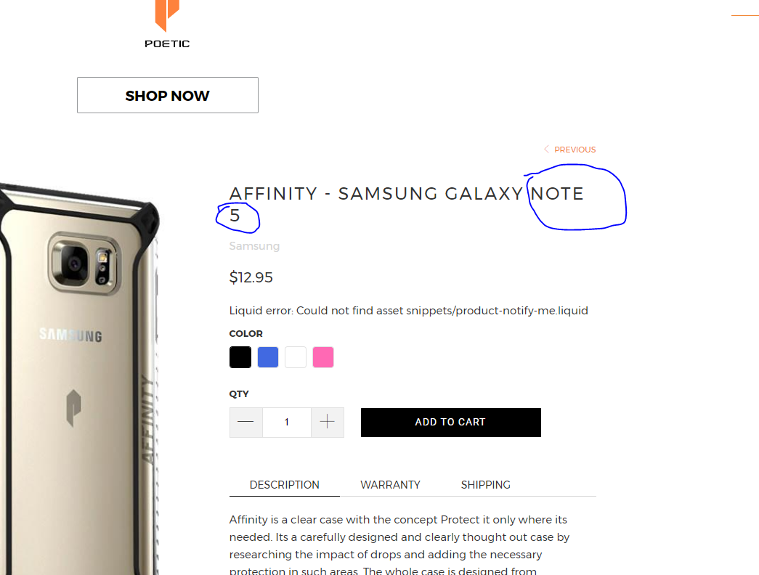

13. it sould be a single word

<https://poeticcases.myshopify.com/collections/revolution/products/revolution-fire7>

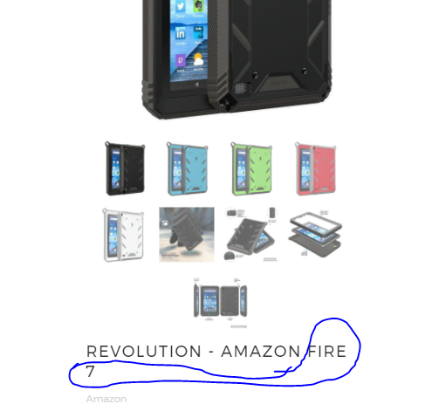

14. grid is not set to the horizontal line

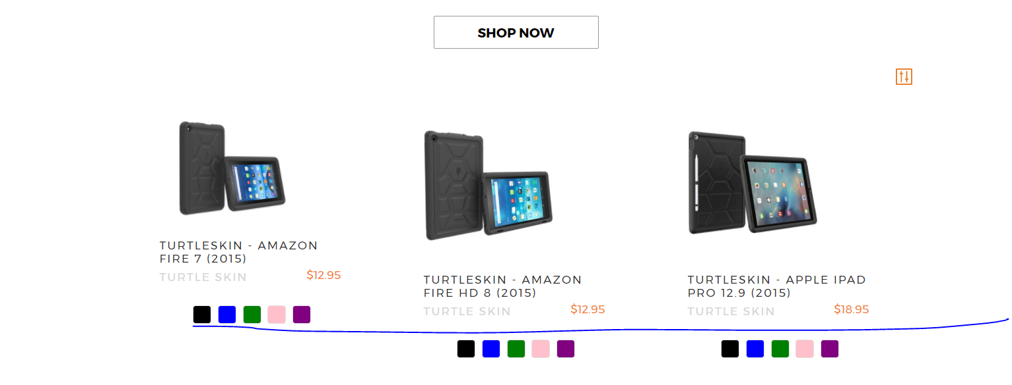

15. diff to touch in mobile mode need some padding

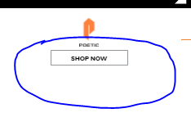

16.